Chapter 10, Solution 53.

Use the concept of source transformation to find V_{o} in the circuit of Fig. 10.97.

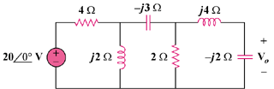

Figure 10.97
For Prob. 10.53.

Solution

We transform the voltage source to a current source to obtain the circuit in Fig. (a).
Let

4

j2

-j2

50 A

2

j4

-j3

+

V_{o}

(a)

With these, the current source is transformed so that the circuit becomes that shown in Fig. (b).
Let

j4

-j3

(b)

+

V_{o}

2

-j2
+

V_{s}

Z_{s}

With these, we transform the voltage source in Fig. (b) to obtain the circuit in Fig. (c).

j4

(c)

+

V_{o}

2

I_{x}

-j2

Z_{x}
Let

j4

(d)

+

V_{o}

-j2
+

V_{y}

Z_{y}
With these, we transform the current source to obtain the circuit in Fig. (d).
Using current division,
(3.529 – j5.883) V

= 6.86 ∠–59.04° V

